# INDIAN SPECIFIC

[**Grow your business with Unlimit's payment infrastructure**](https://www.in.unlimit.com/)

**Table of Contents**

|  |  |  |
| --- | --- | --- |
| S.No | Section Title | Page No. |
| 1 | **Introduction** | **2** |
| 2 | **Supported Payment Gateway Flows** | **2** |
| 3 | **Step-by-Step Guide to Payment Gateway Integration** | **2** |
| 4 | **Mandatory Security Best Practices** | **3** |
| 5 | **Supported Currencies for Payment Processing & Settlement** | **4** |
| 6 | **Supported Payment Methods** | **4** |
| 7 | **API Section** | **4** |
|  | **7.1 Endpoints for India** | **4** |
|  | **7.2 Postman Collection** | **4** |
|  | **7.3 Set of Available APIs** | **4** |
| 8 | **Transaction Life Cycle Statuses & Decline Codes** | **5** |
| 9 | **Troubleshooting Common Integration Issues** | **5** |
|  | **9.1 Merchant Account Dashboard Login Issue** | **5** |
|  | **9.2 Account Reactivation & OTP Reset** | **5** |
|  | **9.3 Retrieving Wallet Credential** | **6** |
|  | **9.4 Payment Links** | **7** |
|  | **9.5 Return URL Configuration** | **7** |
|  | **9.6 Callbacks / Webhooks** | **7** |
|  | **9.7 Onboarding Issue** | **7** |
|  | **9.8 Settlement Issue** | **7** |
|  | **9.9 Chargeback / Risk Concerns** | **7** |
| 10 | **References and Resources** | **8** |

**UNLIMINT IN PRIVATE LIMITED**

# CIN: U74999HR2021FTC097313, Registered Office: 14th Floor, Wing 1, AIPL Business Club, Sector 62, Gurgaon—122018, Haryana, Email id: contact.india@unlimint.in, Tel. no.: +91 124 4938457

1. **Introduction**

We encourage you to refer to the main document as the single source of truth, as it contains all the essential information. Merchants are required to fully adhere to the guidelines outlined in this primary document. This specific section has been created to highlight the details relevant to India, offering a quick reference for the most common queries raised by clients. It is designed to make it easier to search for Indian-specific information within the global document.  
  
Integration Guides: [**https://integration.unlimit.com/doc-guides/mylvyrw7nxiom-homepage**](https://integration.unlimit.com/doc-guides/mylvyrw7nxiom-homepage)

1. **Supported Payment Gateway Flow**  
     
   **1. Payment Page / Redirection / Non-Seamless flow**

The user is redirected to a dedicated payment page or an unlimited page to securely complete the transaction. This flow ensures a seamless experience while managing sensitive payment details.

**2. Gateway Mode / Seamless flow**

In this mode, the control of the payment process lies entirely with the client. However, to ensure the security of the transaction, the client must be **PCI-DSS certified** to comply with industry security standards.

**3. True Gateway Mode (Server-to-Server Flow)**

This mode facilitates a direct communication between the server and the payment gateway, enabling a more secure and efficient transaction process without the need for user redirection.

**Please refer to the link for the detailed flow:** [**Payment Integration Types**](https://integration.unlimit.com/doc-guides/v396nzw6ayeza-payment-page-mode)

1. **Step-by-Step Guide to Payment Gateway Integration**

**3.1 Sandbox Account Activation**

• **Account Manager**: Assists with Sandbox account creation.

• **Activation Email**: Client receives an activation email with login credentials.

• **MA Dashboard**: Access wallet credentials and configure Return URLs & Callbacks in Settings.

**3.2 Testing in the Sandbox Environment**

• **Complete Flow Testing**: Test the entire payment process in the Sandbox environment.

• **End-to-End Validation**: Client’s tech team ensures all use cases are covered (success, failures, refunds, etc.).

**3.3 Post-Sandbox Testing**

• **Pre-Prod Testing**: Conduct tests and validate the complete flow in the production environment before going live with customers.

• **Production Activation**: Request the Production Activation link from the Account Manager. It will be sent to the registered email, similar to how the Sandbox activation link was received.

**3.4 Production Flow Activation**

• **Final Testing**: Conduct final checks in the production environment by replacing the endpoints and wallet credentials. Ensure validation from your development team and confirm that they are following the documentation.

• **Go Live**: Once you are satisfied with the flow in the production environment, open the portal for customer transactions.

1. **Mandatory Security Best Practices**

**4.1 Use SSL/TLS Encryption**

Secure data transmission between the client, merchant, and payment gateway using SSL/TLS encryption to prevent unauthorized access and eavesdropping.

**4.2 PCI-DSS Compliance**

PCI-DSS compliance is mandatory for gateway modes that process card transactions, ensuring the secure storage and processing of payment data to protect against data breaches.

**4.3 Callback and Signature Verification**

Implement callback mechanisms and signature verifications to maintain data integrity and prevent tampering during transaction processing. Please find the link below to implement the same.

Callback can be configured from the Merchant Account Dashboard under Wallet settings.

<https://integration.unlimit.com/api-reference/98kz48r47q7rc-request-format>

**Important:** Please make sure to whitelist the following IP addresses to ensure smooth integration:

**Sandbox Environment:** 3.108.172.198

**Production Environment:** 65.0.189.225

**4.4 API Security**

Keep production wallet credentials confidential and secure.   
We use strong authentication protocols, such as OAuth, for API access to safeguard sensitive information. This Auth token needs to use in All the API’s that client is consuming at his end.

**4.5 Fraud Detection and Monitoring**

Continuously monitor transactions for unusual patterns or activities (e.g., multiple failed attempts or large transactions) to detect and prevent fraud.

1. **Supported Currencies for Payment Processing & Settlement**

Currently, we support **INR** (Indian Rupee) for both payment processing and settlement. However, we are actively working on expanding our currency offerings and will be adding additional currencies in the near future.

1. **Supported Payment Methods**

We support a variety of popular payment methods in India, including:

* **UPI**
* **Cards**
* **Net Banking**

For a complete list of supported card methods, please visit:

[**Payment Methods-India**](https://integration.unlimit.com/doc-guides/ci8k5zm86k3ny-card-methods#india)

1. **API Section**
   1. **Endpoints for India**

|  |  |
| --- | --- |
| **Sandbox:** | <https://sandbox.in.unlimit.com/api/> |
| **Production:** | <https://psp.in.unlimit.com/api/> |

* 1. **Postman Collection**

Here you can find link to our Postman collection [**Indian APM**](https://documenter.getpostman.com/view/10451813/SzKSTzVu#292b6d99-f7be-41a9-a338-0a84fb0dc21d)

* 1. **Set of Available APIs**

|  |  |  |
| --- | --- | --- |
| **S.NO** | **API** | **API Links** |
| 1 | **Authentication API** | [Auth Token](https://integration.unlimit.com/api-reference/5587sjsdwg45e-api-tokens-obtaining) |
| 2 | **Create Payment API (Select the respective mode from Request/ response to get the relevant parameters)** | [Create payment](https://integration.unlimit.com/api-reference/83ac95d0eaa7a-create-payment)  **Additional Mandatory Parameters (Phone & Email ID)** |
| 3 | **Get API / Inquiry / Status Check API** | [Get Payments Information](https://integration.unlimit.com/api-reference/cf370d816486e-get-payments-information)  [Get Payment Information](https://integration.unlimit.com/api-reference/6300d5bb967bd-get-payment-information) |
| 4 | **Implement Webhooks/ Callbacks Signature verification** | [Callbacks](https://integration.unlimit.com/api-reference/98kz48r47q7rc-request-format) |
| 5 | **Settlement API** | [Settlement Guide](https://integration.unlimit.com/doc-guides/qs7kllcd0gcmi-case-with-callback)  [Settlement API References](https://integration.unlimit.com/api-reference/07a0b977e4ab8-initiate-the-reports-preparation) |
| 6 | **Refund API** | [Refund API References](https://integration.unlimit.com/api-reference/32dc9d1915c76-create-refund) |
| 7 | **Fetching Netbanking Bank codes (Get Request)** | Prod: <https://psp.in.unlimit.com/api/banks/netbankinginr/inr>  Sandbox: [https://sandbox.in.unlimit.com/api/banks/netbankinginr/inr](https://psp.in.unlimit.com/api/banks/netbankinginr/inr) |
| 8 | **Bin Fetch Api** | [Get Card Information](https://integration.unlimit.com/api-reference/0567f2013c8ec-get-card-information) |
| 9 | **Payment Link / Invoice** | [Payment link Guide](https://integration.unlimit.com/doc-guides/vejut2c18ng0y-p-payment-link)  [API Reference](https://integration.unlimit.com/api-reference/d082ab6521c9f-create-an-invoice) |

1. **Transaction Life Cycle Statuses & Decline Codes**

For detailed information about the transaction life cycle statuses and decline codes, please visit the following links:

* [**Transaction Life cycle & statuses**](https://integration.unlimit.com/api-reference/8giy3zxc3fv0m-transaction-life-cycle-diagram)
* [**Decline codes**](https://integration.unlimit.com/api-reference/9uwegz2nrgnr3-decline-codes)

1. **Troubleshooting Common Integration Issues**

Guidelines for resolving integration problems and errors during the payment gateway setup.

* 1. **Merchant Account Dashboard Login Issue**
* Click the link in the email from Unlimit to create your password.
* Use your email and new password to log in.
* Set up two-factor authentication (2FA) using a QR code.
* Complete 2FA setup with Google Authenticator, DUO or any another app.
* Once 2FA is set up, access your merchant account dashboard.
  1. **Account Reactivation & OTP Reset**

Please send an email to **support@in.unlimit.com** with the following details:

* Your Username/Registered Email ID for Merchant Account Dashboard
* Specify the environment (Production/Sandbox)
  1. **Retrieving Wallet Credential:**

To obtain API credentials, please follow the steps below:

1. Log in to the Merchant Account Dashboard.
2. Go to the Settings menu (under the user icon).
3. Navigate to the WALLETS section, click on the wallet ID, and scroll down the page to view the credentials using the **one-time code** generated by your mobile device to view credentials for this terminal.

Same steps can be checked with the UI screenshot shared below

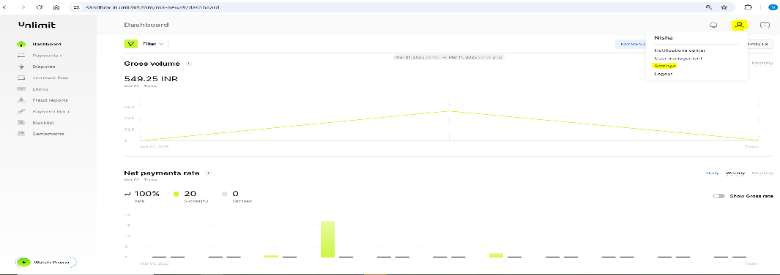

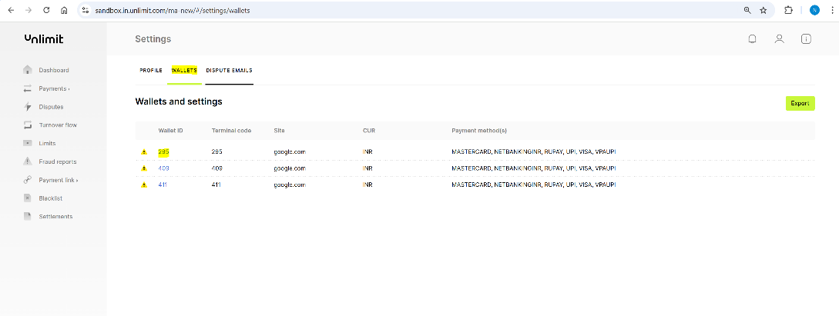

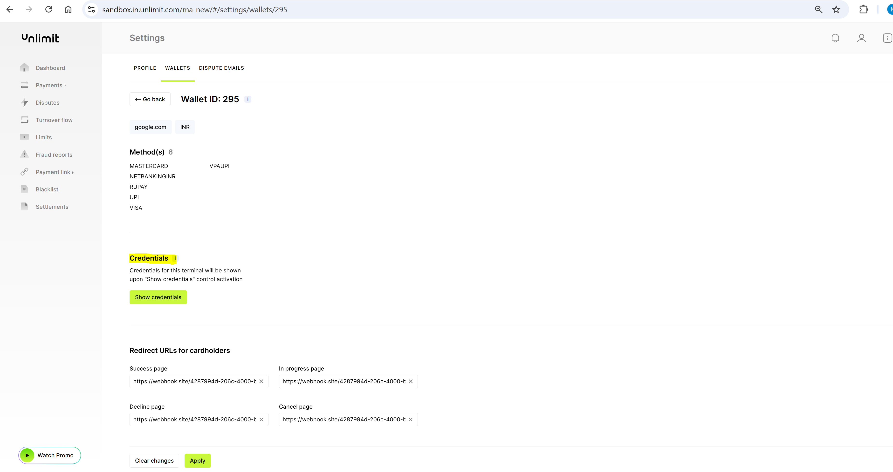

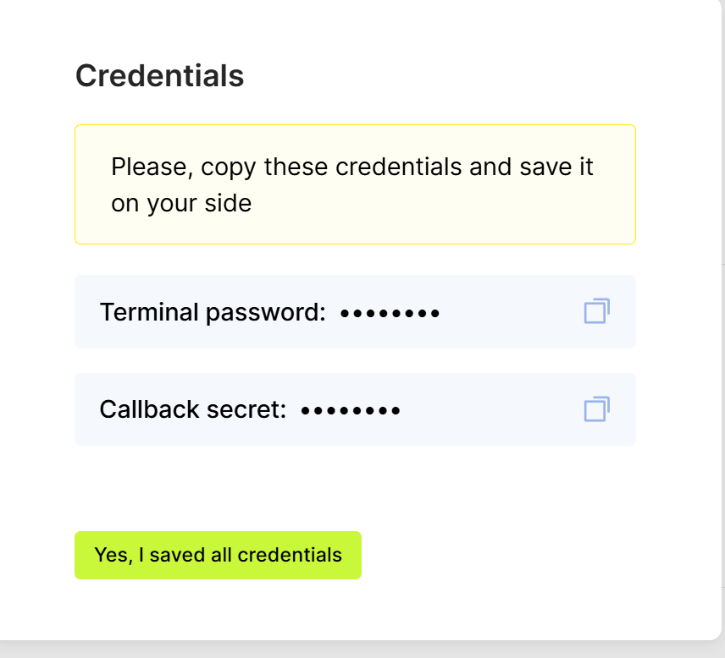

* 1. **Payment Links**

Yes, we support Payment Links for invoices and billings. For more details on Payment Links, please check this link: [**Payment link Guide**](https://integration.unlimit.com/doc-guides/vejut2c18ng0y-p-payment-link) **&** [**API Reference**](https://integration.unlimit.com/api-reference/d082ab6521c9f-create-an-invoice)

* 1. **Return URL Configuration:**

Return URLs can be configured from the Merchant Account Dashboard and same can be passed in the create Payment Request.

The priority of return URLs from the API is higher than from the dashboard.

* 1. **Callbacks/ Webhooks**

Callback can be configured from the Merchant Account Dashboard under Settings and no whitelisting is required from the Unlimit end. For more details, refer to section 4.3, 'Callback and Signature Verification' on page 3

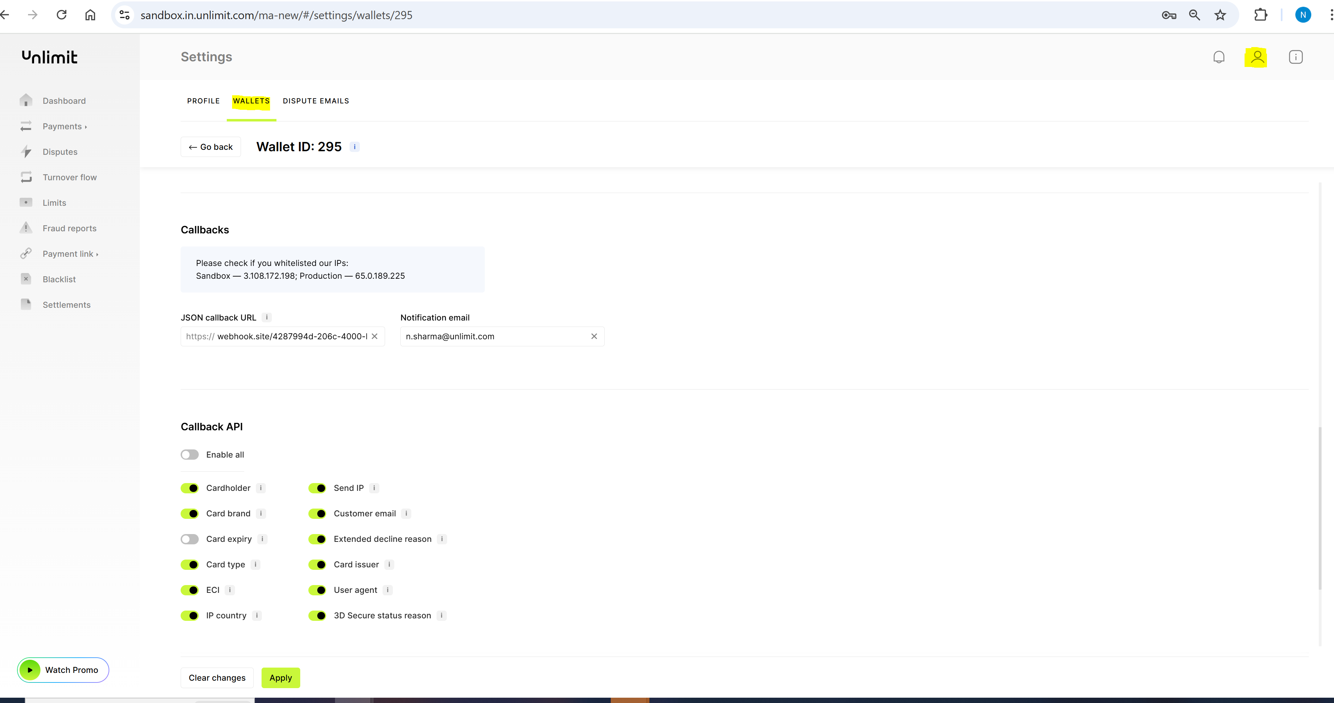

* 1. **Onboarding Issue**

Please send an email to **onboarding.in@unlimit.com** with the error screenshot and a complete end-to-end video.

* 1. **Settlement Issue**Please reach out to [**financeops.in@unlimit.com**](mailto:financeops.in@unlimit.com) with your Wallet, Transaction Receipt and Unlimit Order ID.
  2. **Chargeback/ Risk concerns**

Please reach out to Mohammad Haris at **m.rahman@unlimit.com** regarding Chargeback/Risk concerns.

1. **References and Resources**

For technical, integration or production support, please contact: [**support@in.unlimit.com**](mailto:support@in.unlimit.com)

[**Grow your business with Unlimit's payment infrastructure**](https://www.in.unlimit.com/)

**UNLIMINT IN PRIVATE LIMITED**

# CIN: U74999HR2021FTC097313, Registered Office: 14th Floor, Wing 1, AIPL Business Club, Sector 62, Gurgaon—122018, Haryana, Email id: contact.india@unlimint.in, Tel. no.: +91 124 4938457